**The report for trademark normalization risk monitoring**

商标常态化风险监测报告

Dear Sir/Madam,

Entrusted by Jining City Intellectual Property Rights Protection Center Province, Shandong Province, we conduct regular American trademark risk monitoring for your company's figure trademark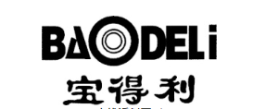. The monitoring cycle is once every 6 months. The reference data of this monitoring report is as of May 10, 2024.

During the monitoring work, we have not detected trademark similar to your company's trademark and this trademark has been registered in USA. In order to avoid disputes in US to Longchang Plastic, we provide suggestions for your reference, details please see the attached report.

尊敬的先生/女士，您好：

我们接到济宁市知识产权事业发展中心的委托，为贵公司图形商标进行美国商标常态化风险监测，监测周期为每 6 个月一次，本次监测报告参考数据截至2024年5月10日。

在本次监测中，我们未监测到与贵公司商标的近似商标，且在美国注册了商标，为避免贵公司在使用时出现纠纷，我们提供了预警建议，供贵公司参考，详见附页。

监测商标：

企业：山东隆昌塑业有限公司

类别：17

监测时间：2024-05-10

监测结果：暂未发现他人申请相同/近似的商标。

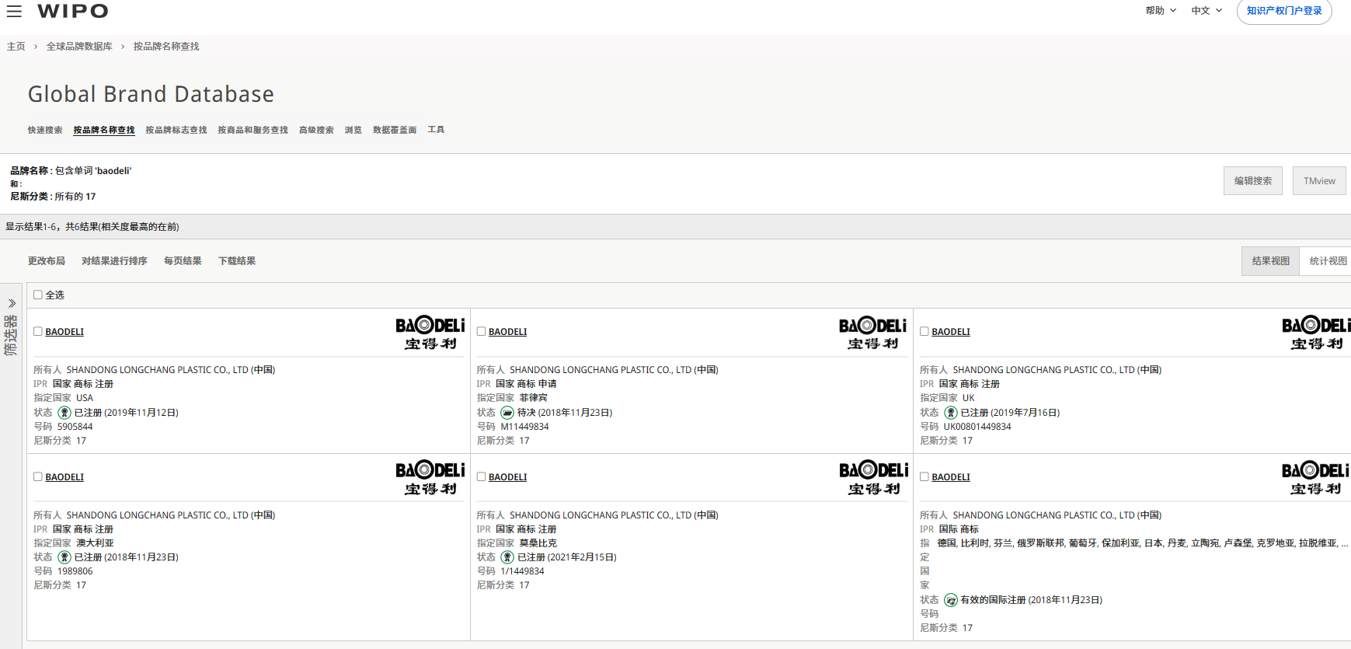

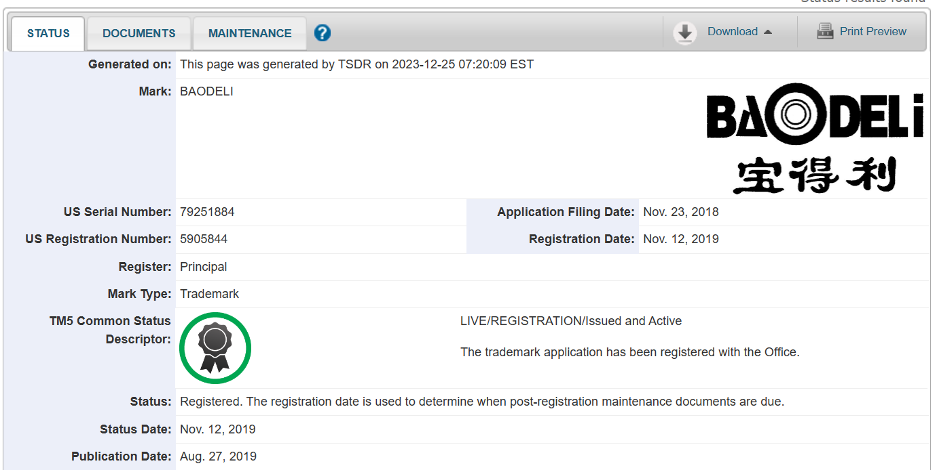

预警提醒：

在本次监测中，我们未监测到与贵公司商标的近似商标，因为该商标含有中文+图案，在美国被侵权的可能性较低，但是也需要进行定期的商标监控，以避免被侵权的风险。

**Monitoring trademark:** 

**Enterprise:** Shandong Longchang Plastic Co.,Ltd.

**IC：**17

**Monitoring time:** 2024-05-10

**Monitoring results:** No identical / similar trademarks applied by others.





Warning reminder:

During the monitoring work, we did not detect trademarks similar to your company's trademark,for the trademark contains text + figure and the possibility of infringement in the United States is low. However, regular trademark monitoring is also needed to avoid the risk of infringement.

济宁市海外知识产权服务（美国）工作站

Jining Overseas Intellectual Property Service （USA）Workstation

国内专家单位：山东专利工程有限公司

Shandong Patent Engineering Co.,Ltd

海外专家单位：美国思科达律师事务所

Syncoda LLC.



2024年5月10日

May 10,2024