**The report for trademark normalization risk monitoring**

商标常态化风险监测报告

Dear Sir/Madam,

Entrusted by Jining City Intellectual Property Rights Protection Center Province, Shandong Province, we conduct regular American trademark risk monitoring for your company's trademark “” The monitoring cycle is once every 6 months. The reference data of this monitoring report is as of May 10, 2024.

During the monitoring work, we detect trademark  registered by DUKE University on USPTO and at the same time we found that the status of your company's trademark in USPTO is rejected. In order to avoid disputes in US to Shenli Rigging, we provide suggestions for your reference, details please see the attached report.

尊敬的先生/女士，您好：

我们接到济宁市知识产权事业发展中心的委托，为贵公司“”的商标进行美国商标常态化风险监测，监测周期为每 6 个月一次，本次监测报告参考数据截至2024年5月10日。

在本次监测中，我们在美国商标局网站查询到了杜克大学注册DUKE商标，同时也查询到了贵公司商标在USPTO的商标状态为驳回，为避免贵公司的该商标在美国使用时出现纠纷，我们提供了预警建议，供贵公司参考，详见附页。

监测商标：

企业：山东神力索具有限公司

类别：6

监测时间：2024-05-10

监测结果：在USPTO中的状态为驳回，同时查询与美国杜克大学的商标存在近似。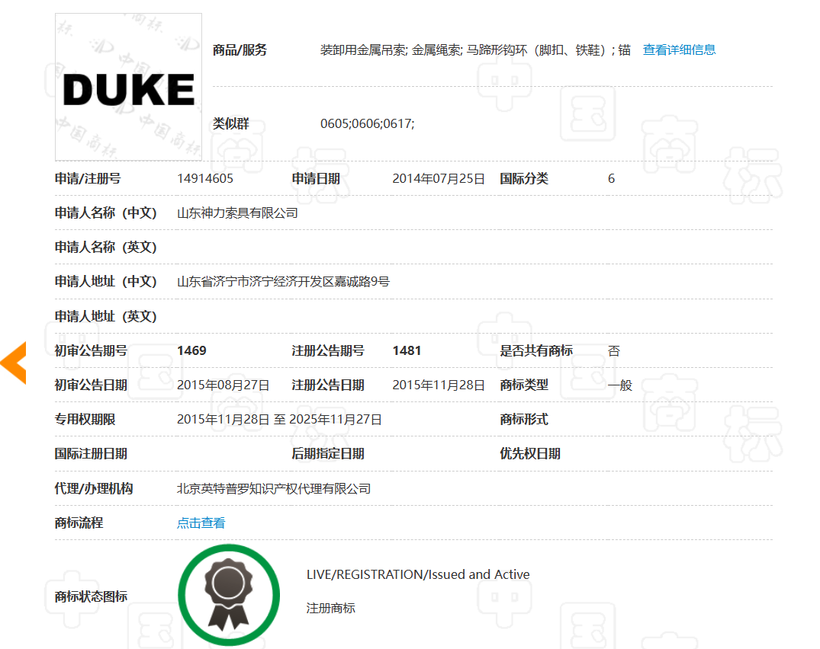

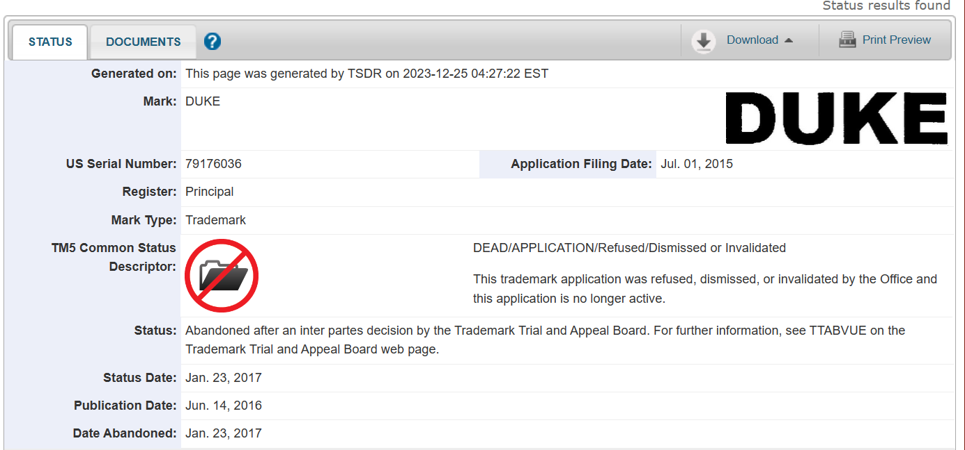

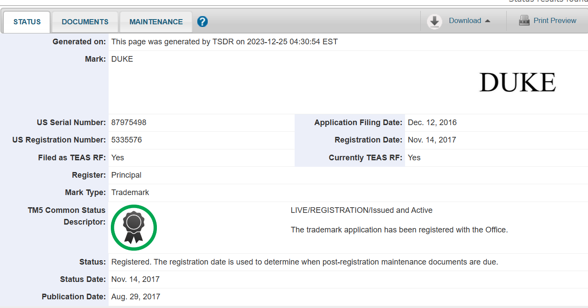

预警提醒：

山东神力索具有限公司于2015年7月01日在美国USPTO申请注册“”文字的商标，该商标在国际上除美国外，还通过马德里途径注册了英国、澳大利亚、新加坡、德国、挪威等多个国家和地区。

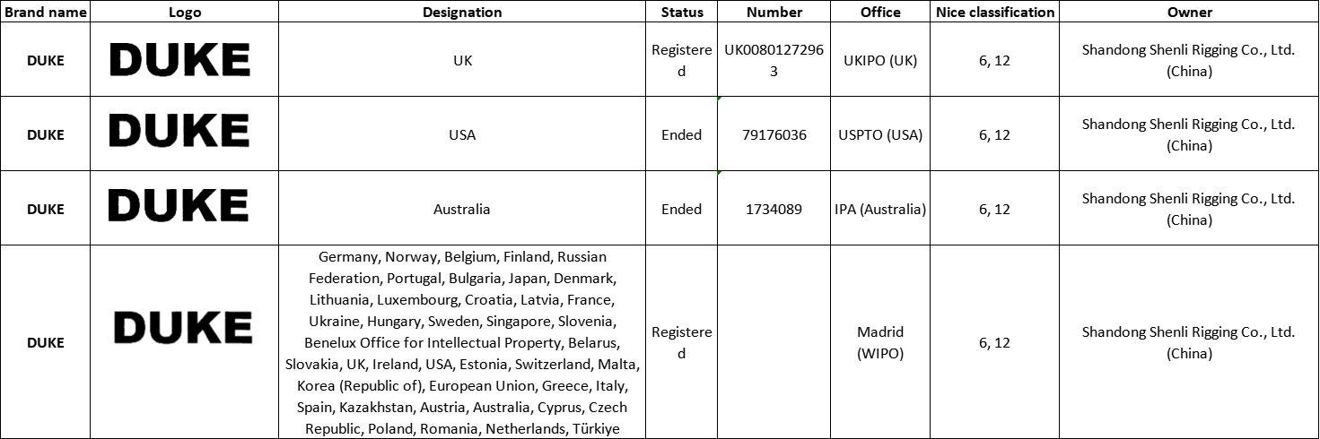

在本次监测中，我们监测到与贵公司商标的近似商标，虽然贵公司通过马德里途径进行了充分的商标布局，但是在美国却被驳回，为避免贵公司在使用时出现纠纷，我们建议贵公司对该商标的设计进行修改，如增加图案，以提高在美国授权的可能性。

**Monitoring trademark:** 

**Enterprise:** Shandong Shenli Rigging Co., Ltd

**IC**：6

**Monitoring time:** 2024-05-10

**Monitoring results:** The status of trademark in USPTO is rejected, and the trademark is detected to be similar to the trademark of Duke University.







**Risk warning:**

Shenli Rigging applied for the registration of trademark  in the United States on July 1,2015. In addition to the United States, the trademark is also registered in the United Kingdom, Australia, Singapore, Norway, Germany and other countries and regions through Madrid.



During the monitoring work, we have detected the trademark similar to the trademark of your company. Although your company made full trademark layout through Madrid, it was rejected in the United States. In order to avoid your company disputes in use, we suggest that your company modify the trademark design, such as increase the number of patterns, to improve the possibility of being authorized in the United States.

济宁市海外知识产权服务（美国）工作站

Jining Overseas Intellectual Property Service （USA）Workstation

国内专家单位：山东专利工程有限公司

Shandong Patent Engineering Co.,Ltd

海外专家单位：美国思科达律师事务所

Syncoda LLC.



2024年5月10日

May 10,2024