**The report for trademark normalization risk monitoring**

商标常态化风险监测报告

Dear Sir/Madam,

Entrusted by Jining City Intellectual Property Rights Protection Center Province, Shandong Province, we conduct regular American trademark risk monitoring for your company's figure trademark . The monitoring cycle is once every 6 months. The reference data of this monitoring report is as of May 10, 2024.

During the monitoring work, we have detected your company’s trademark  is rejected on USPTO. In order to avoid disputes in US to Grand Seasonic Sports Equipment, we provide suggestions for your reference, details please see the attached report.

尊敬的先生/女士，您好：

我们接到济宁市知识产权事业发展中心的委托，为贵公司图形商标进行美国商标常态化风险监测，监测周期为每 6 个月一次，本次监测报告参考数据截至2024年5月10日。

在本次监测中，我们在美国商标局网站查询到了贵公司商标在USPTO的商标状态为驳回，为避免贵公司的该商标在美国使用时出现纠纷，我们提供了预警建议，供贵公司参考，详见附页。

监测商标：

企业：山东圣邦海韵体育用品股份有限公司

类别：28

监测时间：2024-05-10

监测结果：暂未发现他人申请相同/近似的商标。

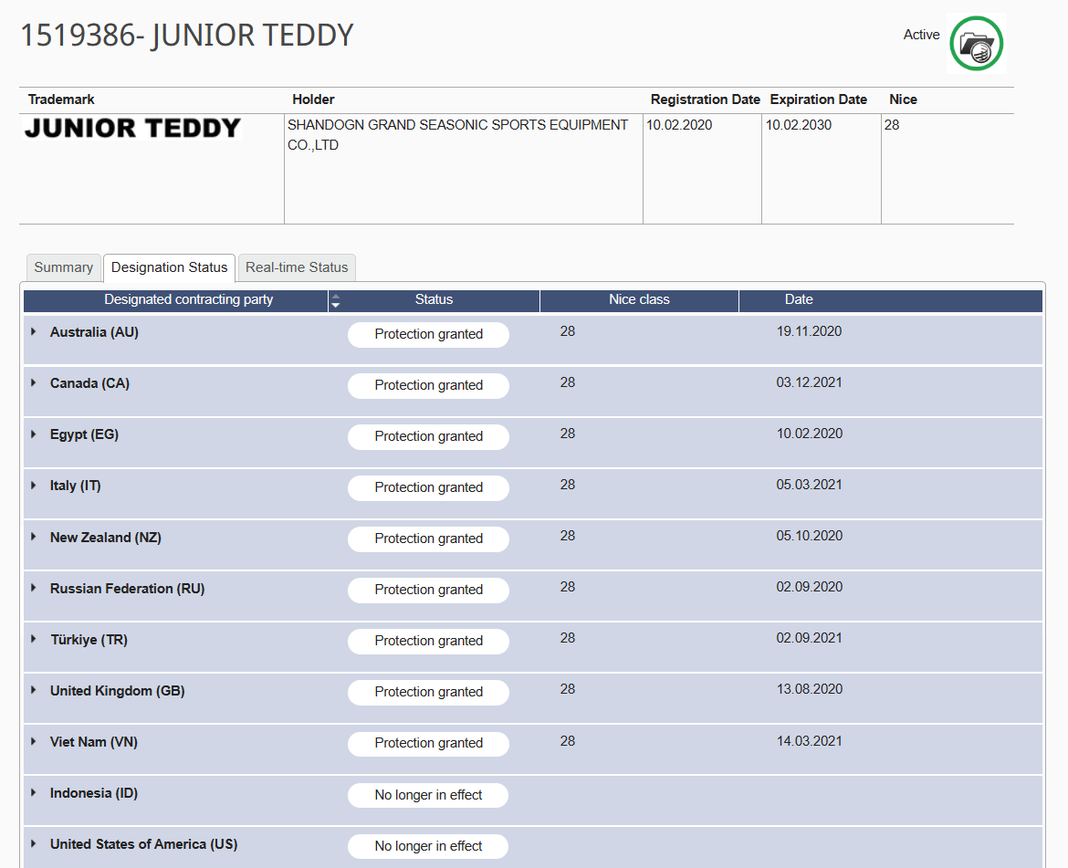

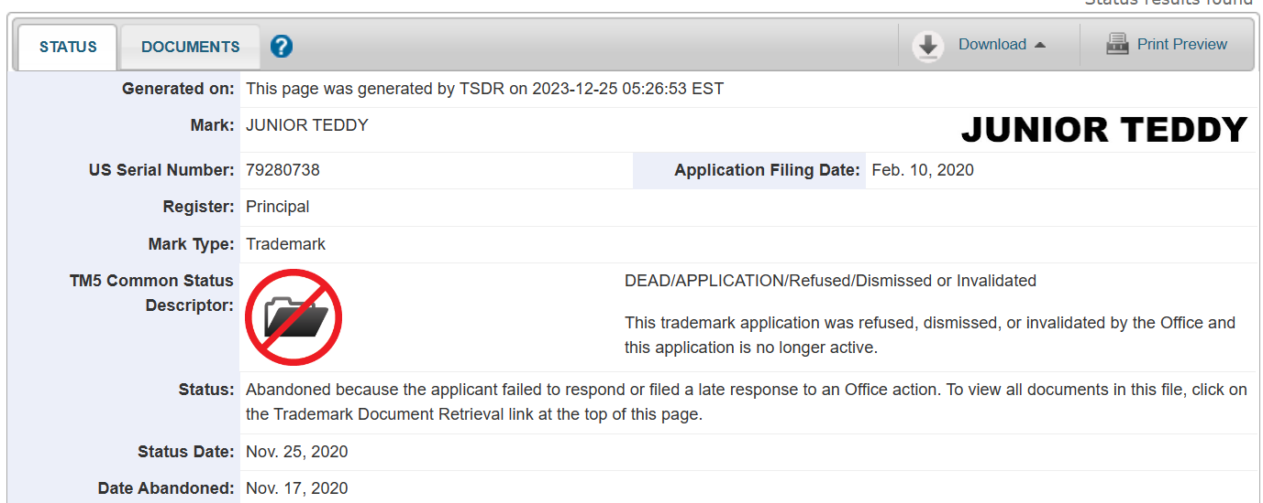

预警提醒：

在本次监测中，我们监测到与贵公司商标通过马德里途径进入了澳大利亚、埃及、加拿大等国，但是在进入美国时，2020年4月29日收到答复审查意见通知，但是贵司没有在18个月内答复，因此最终收到了美国的驳回通知。考虑到贵司的产品未来仍有进入美国可能性， 为了避免贵公司在使用时出现纠纷，我们建议贵公司对该商标的设计进行修改，如增加图案，以提高在美国授权的可能性。

**Monitoring trademark：**

**Enterprise:** Shandong Grand Seasonic Sports Equipment Co.,Ltd.

**IC：**28

**Monitoring time:** 2024-05-10

**Monitoring results:** No identical / similar trademarks applied by others.





**Risk warning:**

During the monitoring work, we detected that the trademark  of your company entered Australia, Egypt, Canada and other countries through Madrid. However, since your company did not reply within 18 months after entering the United States and receiving the notice of replying for review opinion on April 29,2020. , the notice of rejection from the United States is finally received. Considering that your products may still enter the United States in the future, in order to avoid disputes when you’re using, we suggest that your company modify the design of the trademark, such as adding patterns, to improve the possibility of authorization in the United States.

济宁市海外知识产权服务（美国）工作站

Jining Overseas Intellectual Property Service （USA）Workstation

国内专家单位：山东专利工程有限公司

Shandong Patent Engineering Co.,Ltd

海外专家单位：美国思科达律师事务所

Syncoda LLC.



2024年5月10日

May 10,2024